

**MSc in Clinical Nutrition and Dietetics**

**FORM E Reflective Diary**

|  |
| --- |
| **Student name: Student number:**  **Date:** |

Your reflection can be submitted in writing or as an audible recording. Regardless, it must contain 6 aspects as outlined in the Gibbs model below.

**Gibb’s model of reflection**

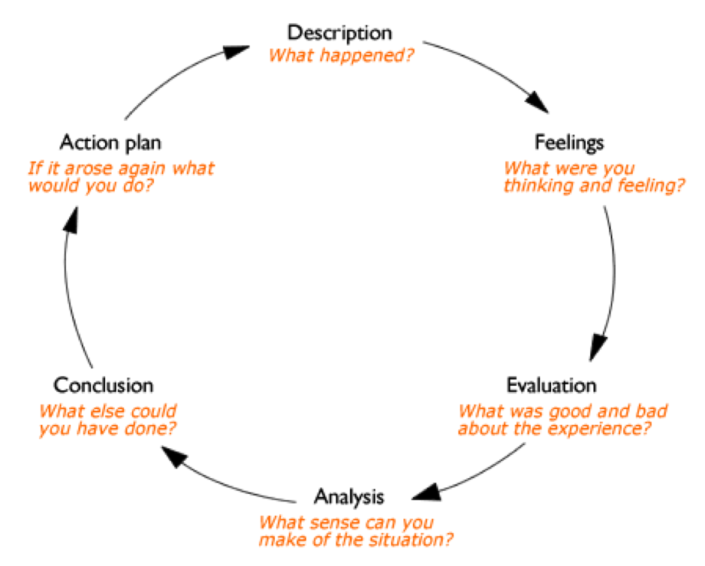

**AT LEAST ONE REFLECTION NEEDS TO BE COMPLETED ON YOUR EXPERIENCE OF OBTAINING FEEDBACK FROM SERVICE USERS USING THE CARE MEASURE.**

**Reflection (to be discussed with Practice Tutor and/or Practice Educator as appropriate):**

|  |
| --- |
|  |

**Word Limit 1500**